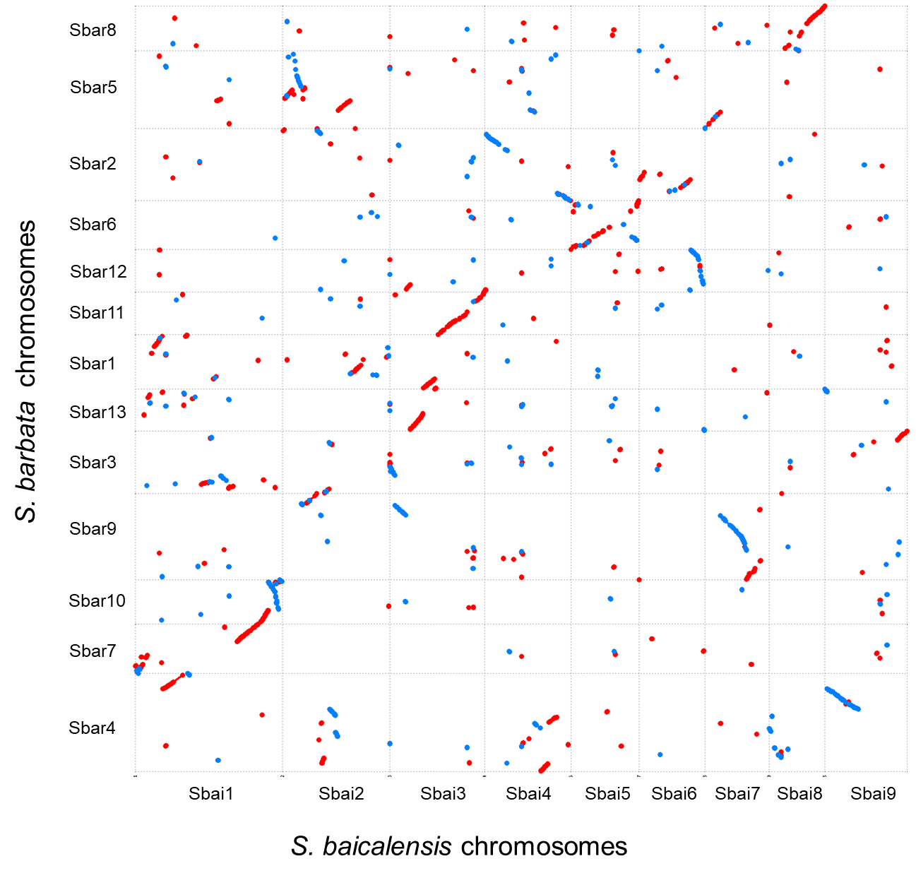

Supplementary Figure S4. The alignment of large-scale DNA sequences between *S. baicalensis* and *S. barbata* with the minimum mapping length of 100 kb.